Testing the topographic wind disruption hypothesis of beetle refugia
Host distribution, thermal load, and terrain-wind effects on Mountain pine beetle attack (Dendroctonus ponderosae) across 1,740 m of relief in the Selkirk Mountains of British Columbia

Refugia from mountain pine beetle (Dendroctonus ponderosae) are hypothesised to form where host is sparse enough for wind to disrupt the aggregation pheromone plume mass attack depends on, never tested spatially. We test it across 168 km² of inventoried forest and 1,740 m of relief in British Columbia, combining an aerial survey of beetle-caused mortality (1999-2015) with inventory host cover and Global Wind Atlas speed. Attack is unimodal, peaking near 1,430 m. Below 1,900 m that peak is host, and conditioning on lodgepole presence removes it; above 1,900 m it is not, and attack halves while pine cover thins only slightly. We find no wind effect. Orthogonalised against a linear elevation term, wind is the strongest negative predictor in host-bearing stands, clearing the interval test at every severity threshold above trace; but a unimodal response leaves elevation’s curvature inside that term, and refitting it as a quadratic or spline collapses the coefficient everywhere. The signal is a specification artefact. Winter minima at every station within 100 km fall ten degrees short of lethal, so the cold mechanism is degree-day accumulation, not freeze. Elevation explains 0.63 of the wind surface’s variance landscape-wide but 0.80 within a 2 by 4 km clip, where the estimate reverses sign; grain scarcely matters. At the extent disturbance ecology usually adopts, this study would have reported the opposite; with severity collapsed to presence, no result at all; and without a host layer, absence of pine misread as refugia.
Keywords: beetle refugia; mountain pine beetle; aerial overview survey; Global Wind Atlas; scale dependence; collinearity

1. Introduction
Disturbance refugia, defined by Krawchuk et al. (2020; 2025) as locations disturbed less severely or less frequently than the surrounding landscape, have become an organising concept for forest conservation under climate change. The concept is well developed for fire and much less so for insects. Krawchuk et al. (2020) note that few studies have explicitly identified refugia from insect outbreaks, and propose a testable mechanism for the most consequential insect disturbance in western North America: refugia from mountain pine beetle (Dendroctonus ponderosae Hopkins) could occur where host density is lower, thinner stands admitting more wind and so disrupting the aggregation pheromone communication mass attack depends on.
The hypothesis is attractive because it is mechanistic and because each of its parts is independently plausible. Mass attack requires beetles to overwhelm host defences in a coordinated pulse, and the coordination is chemical. Beetle dispersal above the canopy is a flight behaviour sensitive to ambient conditions (Gray et al. 1972; Jones et al. 2019). Thinner stands admit more wind. What has been missing is a spatial test.
Cartwright (2018) came closest. Working at 30 m in lodgepole and whitebark pine in southern Oregon, she identified refugia from Landsat moisture anomalies during a 2009 drought and beetle outbreak and modelled their landscape controls. Refugia were associated with shaded slopes, convergent positions, low soil bulk density and thinner stands. The thinner-stand result is the host-density half of the hypothesis, confirmed. But she had no wind surface, so the mechanism went untested.
Testing it requires a wind surface, and that is where the problem starts. Gridded wind products, the Global Wind Atlas among them, are produced by downscaling coarse mesoscale fields over a digital elevation model (Badger et al. 2014; Davis et al. 2023). A surface built this way is in part a transform of the terrain it was draped over. Offered to a model alongside elevation it is not an independent measurement, and the severity of the dependence is a function of extent: a coarse driving field is nearly flat over a few kilometres, so at small extents almost all the variation in the product is terrain. An analyst working at the scale of a burn perimeter or a cluster of field plots, which is where most disturbance ecology is done, is in the worst position and has the least warning.
A second and more elementary trap attends refugia work. A cell that was not attacked may hold no host. Under the Krawchuk et al. (2020) framing this is the difference between what a place is a refugium from and what it is a refugium for, and it cannot be resolved without an independent map of host abundance. The precedent is old and pointed: Hadley (1994) predicted heavier beetle mortality on hot, dry, south-facing slopes and found the reverse, because host density rather than moisture stress governed where attack succeeded.
We take these three problems to one landscape. We ask:
- Does terrain condition beetle-caused mortality once host abundance is accounted for, and where along the elevation gradient does host stop explaining the pattern?
- Does the component of the wind surface that is independent of elevation predict reduced attack where host is present, as Krawchuk et al. (2020) hypothesise?
- How much does the answer to question 2 depend on decisions the analyst makes freely: the extent of the study area, the grain of the cells, and whether damage is coded as a binary or as the ordinal severity class the survey records?
The design makes the third question answerable rather than rhetorical. The same response, predictors and model are refitted across each axis: across the full landscape and inside a 2 by 4 km clip drawn from it, at 25 m, 50 m and 100 m, and at each severity threshold in turn. Two of the three change the answer, and they are not the two that get reported.

2. Materials

2.1 Study area
The Darkwoods Conservation Area lies in the South Selkirk Mountains of southeastern British Columbia. The terrain grid spans 16 by 17.5 km and 1,776 m of relief, from valley bottom to alpine. The modelled area is a subset, because cells carrying no inventory basal area cannot enter a model conditioning on stand structure; Table 1 reports its extent and relief. Both numbers are correct and are not interchangeable. The range crosses the full biogeoclimatic sequence of the southern interior wet belt, from the dry warm Interior Cedar-Hemlock subzones through the moist warm subzones to the Engelmann Spruce-Subalpine Fir zone and its parkland variant (Ketcheson et al. 1991; Braumandl and Dykstra 2005). Lodgepole pine (Pinus contorta var. latifolia), the beetle’s principal host here, occupies the middle of that sequence and is scarce at both ends.
The site description and terrain surfaces are inherited from a companion analysis of conifer regeneration on the same ground (Murphy et al. 2026), which used them to predict seedling intensity after a 2015 wildfire. Disturbance was a predictor there; here it is the response. Figure 1 locates the landscape and shows the three spatial inputs.

2.2 Beetle-caused mortality
The response is the British Columbia Aerial Overview Survey, the operational provincial record of forest health, in which observers sketch-map damage annually from aircraft and label each polygon by year, causal agent, severity class and host species. We take polygons coded IBM, mountain pine beetle, for the outbreak window 1999 to 2015, and rasterise the maximum severity class reached by each cell (n=30, 7,920 ha).
Using the survey rather than a spectral classification is a deliberate trade. Red attack has been mapped from Landsat with improving accuracy (White et al. 2005; Meddens et al. 2013; Ye et al. 2021), but every such product is a model whose errors are spatially structured and not independent of terrain, because illumination, shadow and view angle vary with slope and aspect. For a question about terrain, a response from a terrain-sensitive classifier risks recovering the classifier’s own terrain sensitivity. Sketch-mapping has cruder errors, but they are observer errors, not errors generated by the predictors under test.
The severity scale is anchored to ground measurement. Twenty-eight field plots established in beetle-affected stands in 2020 recorded the basal area of pine killed, spanning 0.6 to 47.4 m2/ha, or 1.3 to 94.7 per cent of plot basal area, and calibrated the spectral mapping used in the companion study (Murphy et al. 2026). Plot coordinates were not recoverable, so the plots calibrate the severity scale but cannot check the spatial placement of individual polygons. We state that limit rather than implying a validation we did not perform.
Figure 1 shows the landscape and the response together. Panel (b) is the elevation surface that defines the grid and panel (d) the survey records this paper models: attack concentrated in a mid-elevation band, sparse in the valley and again along the alpine crest. Panel (c) is the wind surface whose relationship to that terrain the second half of the paper is about.
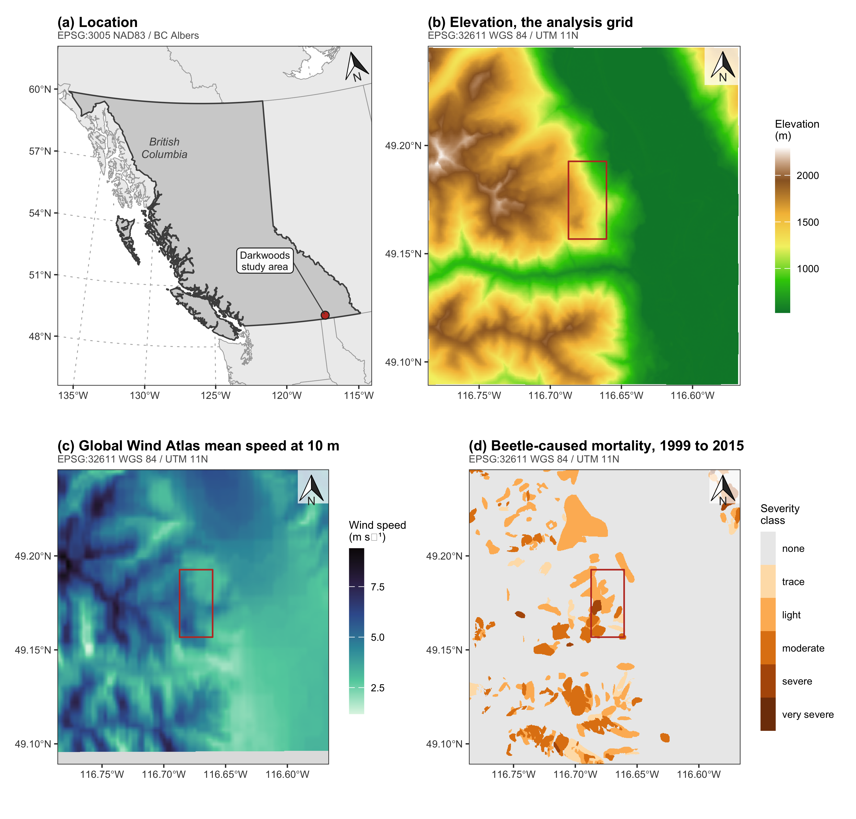
Figure 1: The study area and the three spatial inputs. (a) Location within British Columbia; the marker is a 22 km symbol, not the footprint. (b) The elevation surface, which is the analysis grid. (c) Global Wind Atlas mean speed at 10 m; the shaded southern band lies outside the wind product’s extent. (d) Beetle-caused mortality from the Aerial Overview Survey, 1999 to 2015, as the maximum severity class in any year. The outlined rectangle in (b) to (d) is the 2 by 4 km clip of Section 4.7. Graticules are WGS 84; each panel’s projection is beneath its title.

2.3 Host abundance
Host abundance comes from the provincial Vegetation Resources Inventory, layer VEG_COMP_LYR_R1_POLY, retrieved from the British Columbia Data Catalogue web feature service for the study window. We accumulate the percentage cover of lodgepole pine across the three species slots each polygon records (n = 2,743) and carry stand basal area alongside it.
The inventory’s vintage matters. These polygons carry a reference year of 2014 and an interpretation date of August 2014; the projected date of 31 December 2025 is the growth model’s roll-forward of age, height and volume, not a re-observation. Species composition therefore comes from photography flown in the fourteenth year of a seventeen-year outbreak window.
That is a limitation we cannot remove and should not hide. A stand whose pine was killed early will have been interpreted after the fact, and its recorded lodgepole percentage will be lower than the pine it carried when the beetle arrived. The bias runs in a specific direction: host is under-recorded exactly where attack was heaviest and earliest. It is therefore a candidate explanation for the reversal of the lodgepole coefficient at the severe threshold in Section 4.3. It does not touch the presence-absence distinction the layer is mainly used for, since a stand that carried enough pine to be killed is not recorded as pine-free.
Without this layer the analysis cannot distinguish a refugium from an absence of pine, and Section 4.1 shows that the distinction accounts for most of the apparent terrain signal.
Figure 2 maps both layers. Lodgepole cover is concentrated in the middle of the elevation range and scarce in the valley, which is the pattern the host-conditioning argument turns on: the valley is not lightly attacked because it is sheltered but because it holds almost no host. Basal area defines the analysis frame, and the blank cells in panel (b) are those dropped for want of it.
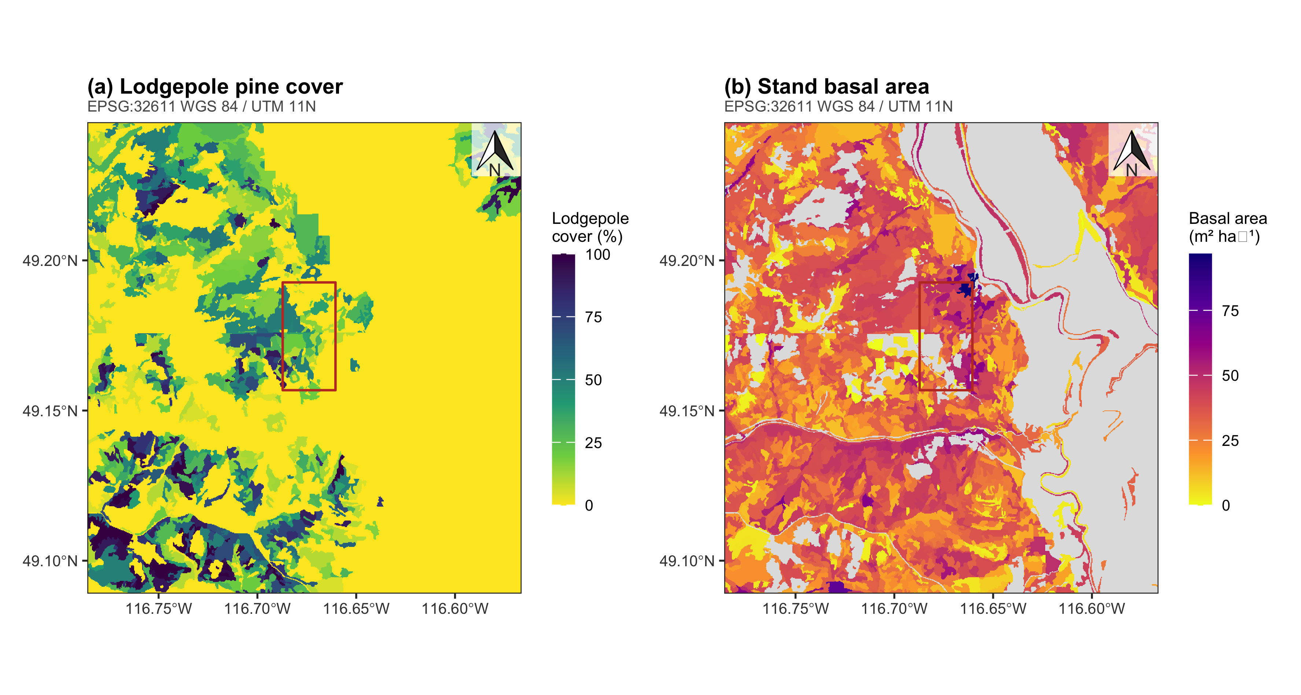
Figure 2: The forest inventory host layers, rasterised onto the analysis grid. (a) Lodgepole pine cover, accumulated across the three species slots each polygon records. (b) Stand basal area, which defines the analysis frame: cells with no recorded basal area are dropped. Unshaded ground is unmapped or non-productive. Projection and scale as in Figure 1.

2.4 Terrain and wind
Terrain surfaces are inherited unchanged from Murphy et al. (2026), which derived them from the 1 m Natural Resources Canada High Resolution Digital Elevation Model (Natural Resources Canada 2017), smoothed, depression-filled by the algorithm of Wang and Liu (2006) and aggregated to 25 m, with compound indices following Beers and Miller (1973) and Parker (1982). We add three surfaces of our own. The first is a topographic position index at a 625 m neighbourhood, because Cartwright (2018) found slope, elevation and heat load among the strongest controls on refugia and reported topographic position alongside them, and the inherited set carried none.
The other two exist because the inherited set carries no aspect information, and so no term that can distinguish a warm slope from a cold one at the same elevation. That matters because the confound this paper cannot resolve is between wind exposure and cold, and aspect bears on the two differently. We compute a heat load index after McCune and Keon (2002), in which aspect is folded about the southwest to northeast axis so that southwest is hottest, and a shelter index after Winstral et al. (2002), the maximum upwind slope angle within 500 m along a bearing, positive where terrain rises upwind and negative on exposed convexities. The Global Wind Atlas supplies speed but no direction, so rather than assume a prevailing bearing we compute the index on all eight cardinal and intercardinal bearings and average them.
The decisive property of both is how they are built. They are derived from the elevation model by trigonometry rather than draped over it by downscaling, and Table 2 shows the consequence: their variance is essentially unrelated to elevation, where the wind product’s is largely elevation. A terrain-derived predictor is not automatically an elevation transform; the distinction is in the construction.
The ruggedness surface carries a documentation gap we state rather than paper over. Its exact formulation is not recorded beyond the citations above, and its distribution is inconsistent with a vector ruggedness measure. We treat it as a reproducible but unnamed ruggedness surface and confine claims to its statistical behaviour.
Ambient wind is Global Wind Atlas mean wind speed at 10 m above ground level. The atlas is built by driving a mesoscale model from reanalysis, generalising the result by the method of Badger et al. (2014) to remove the local terrain and roughness signal, then downscaling it over a digital elevation model and a land-cover roughness map (Davis et al. 2023). Elevation and roughness are inputs to the product, not covariates measured independently of it. That is why it cannot be assumed independent of elevation, and testing that assumption is the second half of this paper.
Figure S1 maps the six derived surfaces. Their point is visual rather than statistical: slope, wetness, ruggedness and topographic position all trace the same drainage network and valley wall, whereas heat load and the shelter index divide the landscape by aspect, picking out southwest-facing ground the others do not distinguish. That is the difference Table 2 quantifies.

2.5 Climate records
Because the interpretation in Section 4.2 turns on whether it is cold enough at the top of the gradient to kill beetles, we assembled the observational record. Hourly observations from the British Columbia Wildfire Service network and daily observations from Environment and Climate Change Canada were retrieved for all stations within 100 km for the winters of the outbreak window. The script in 02.inputs/climate/ streams roughly 2.7 GB and writes the per-station-winter summary the manuscript reads. That division is deliberate: the fetch cannot sit inside a document render, but every decision about which records to believe is made in Section 4.6, in code, and is visible there.
Two screens matter. Many older Wildfire Service sensors floor at exactly -20.0 °C, so a station-winter whose minimum sits on that floor has an unknown true minimum and is excluded; the rule is applied and checked in Section 4.6 rather than inherited. Isolated spikes, colder than both neighbouring observations by more than 15 °C, are rejected as instrument error at the observation level, the one screen that must happen during retrieval because it needs the sub-daily series. One such value, a -40.0 °C daily minimum on a day whose maximum was -4.5 °C and carrying no quality flag, would otherwise have produced exactly the conclusion the record does not support.
This network cannot furnish a temperature surface, for the reasons Section 4.6 sets out. It can establish whether lethal temperatures occur in this region at all, a weaker and sufficient claim.
Table 1: The analysis landscape, and the 2 by 4 km clip drawn from it that the companion study used. The clip samples under two thirds of the relief and under 4 per cent of the cells.
Extent | Cells | Area (km²) | Elevation (m) | Relief (m) | Attacked (%)
full landscape | 266,650 | 168.2 | 528 to 2268 | 1,740 | 20.9
2 by 4 km clip | 9,784 | 6.2 | 654 to 1747 | 1,093 | 45.3

3. Methods

3.1 Inference
The response is heavily clustered, so cell counts vastly overstate independent information. All coefficients carry percentile intervals from a spatial block bootstrap in which the landscape is partitioned into blocks of 40 by 40 cells, roughly 1 km on a side, resampled with replacement 150 times. Blocks of this size exceed any plausible correlation range of the survey polygons. We report the point estimate, the block interval and the proportion of resamples reproducing its sign, and treat a term as supported only when the interval excludes zero.

3.2 Orthogonalisation
Because the wind surface is built over the elevation surface, its coefficient in a model containing elevation is estimated from whatever small part of the joint distribution lets the two vary separately. We therefore replace wind by the residual of wind regressed on elevation, rescaled to unit variance.
It is easy to present this as a remedy for collinearity and it is not one. The substitution is a linear reparameterisation of the same model: fitted values and deviance are unchanged, and by the Frisch-Waugh-Lovell theorem the residualised coefficient is the raw wind coefficient multiplied by the square root of one minus the R² of wind on elevation, with its standard error scaled identically. Every supported-or-not verdict in this paper is therefore numerically the same in both parameterisations, and orthogonalisation buys no precision whatever. What changes is interpretation. The wind coefficient now refers to the part of the wind surface elevation does not explain, which is the quantity the Krawchuk et al. (2020) hypothesis is about, and the elevation coefficient becomes the total elevation association rather than the partial effect at fixed wind. The reparameterisation is worth making for that reason and no other.
Table 2: How much of each candidate predictor is elevation. The wind product is a mesoscale field draped over terrain and is largely an elevation transform. The heat load and shelter indices are computed from the same elevation model by trigonometry and are almost unrelated to it.
Surface | How it is built | R² on elevation
Global Wind Atlas wind speed | mesoscale field downscaled over the DEM | 0.629
Heat load index (McCune & Keon, 2002) | trigonometric function of DEM aspect and slope | 0.000
Shelter index (Winstral, 2002) | maximum upwind slope from the DEM within 500 m | 0.002
Topographic position at 625 m asl | deviation from surrounding DEM mean | 0.021

3.3 Response coding
Krawchuk et al. (2020) warn against coding refugia as a binary, since a refugium is a matter of degree and thresholding discards the signal distinguishing a lightly touched stand from a destroyed one. The survey carries an ordinal severity class, so we can follow that advice. We fit the binary attacked model for comparability with the refugia literature, and alongside it a cumulative logit at each severity threshold. Fitting the thresholds separately rather than imposing a single proportional-odds slope is deliberate, and is the standard diagnostic for whether proportional odds holds; Section 4.3 shows that here it does not.

4. Results

4.1 Host effects by elevation
Table 3: Attack across the elevation gradient, before and after conditioning on lodgepole presence. Conditioning flattens the gradient below 1,900 m but not above it, where attack halves while lodgepole cover rises and stands thin.
band | Cells | Pine % | Basal area | Wind (m/s) | Attacked % (All) | Attacked % (Host)
(500,700] | 37,767 | 2.3 | 29.6 | 3.26 | 6.5 | 23.3
(700,900] | 29,089 | 6.8 | 33.6 | 3.30 | 10.1 | 30.6
(900,1100] | 27,172 | 11.4 | 33.6 | 3.42 | 15.1 | 26.2
(1100,1300] | 26,645 | 18.2 | 32.9 | 3.69 | 29.2 | 31.5
(1300,1500] | 35,264 | 23.3 | 33.3 | 4.17 | 36.0 | 37.4
(1500,1700] | 42,860 | 29.9 | 30.3 | 4.89 | 30.1 | 33.4
(1700,1900] | 48,278 | 30.9 | 29.5 | 5.70 | 21.9 | 28.1
(1900,2100] | 18,354 | 19.5 | 24.0 | 6.70 | 12.2 | 14.6
(2100,2300] | 1,221 | 13.8 | 19.2 | 7.74 | 0.0 | 0.0

Across the full gradient attack is strongly unimodal (Table 3, Figure 3), rising from under three per cent in the valley to a peak near 1,430 m and falling to zero above 2,100 m.
Conditioning on host presence separates that curve into two phenomena. Below roughly 1,900 m the hump is host distribution: among cells containing lodgepole, attack runs between 23 and 37 per cent with no strong trend from the valley bottom upward, and the rise in the raw curve is the rise in pine cover. Attack is 30.2 per cent where lodgepole is present against 12.4 per cent where it is absent.
Above 1,900 m conditioning does not remove the decline. Attack among host-bearing cells falls by about half, while stand basal area falls from 30.0 to 23.5. Stands are thinner and attack is suppressed.
Host cover decides whether this is the pattern the Krawchuk et al. (2020) hypothesis requires, and it depends on the comparison, so we give both. Against the whole gradient below, mean lodgepole cover in host-bearing cells is 38.8 per cent above the threshold against 39.7 per cent below: essentially unchanged, so host scarcity cannot account for an attack rate that more than halves. Against the 1,750 to 1,900 m band immediately below, however, cover is 49.2 per cent, so the top of the gradient carries about 21 per cent less pine than the band beneath it. The first comparison is flattered by the pine-poor valley it includes, which is the denominator problem Section 5.1 is about, and we would be inconsistent to rely on it alone.
The honest reading is that host thins somewhat at the top while attack falls a great deal more, so the conjunction the hypothesis requires holds in the weaker form. It is not the clean case of host holding constant.
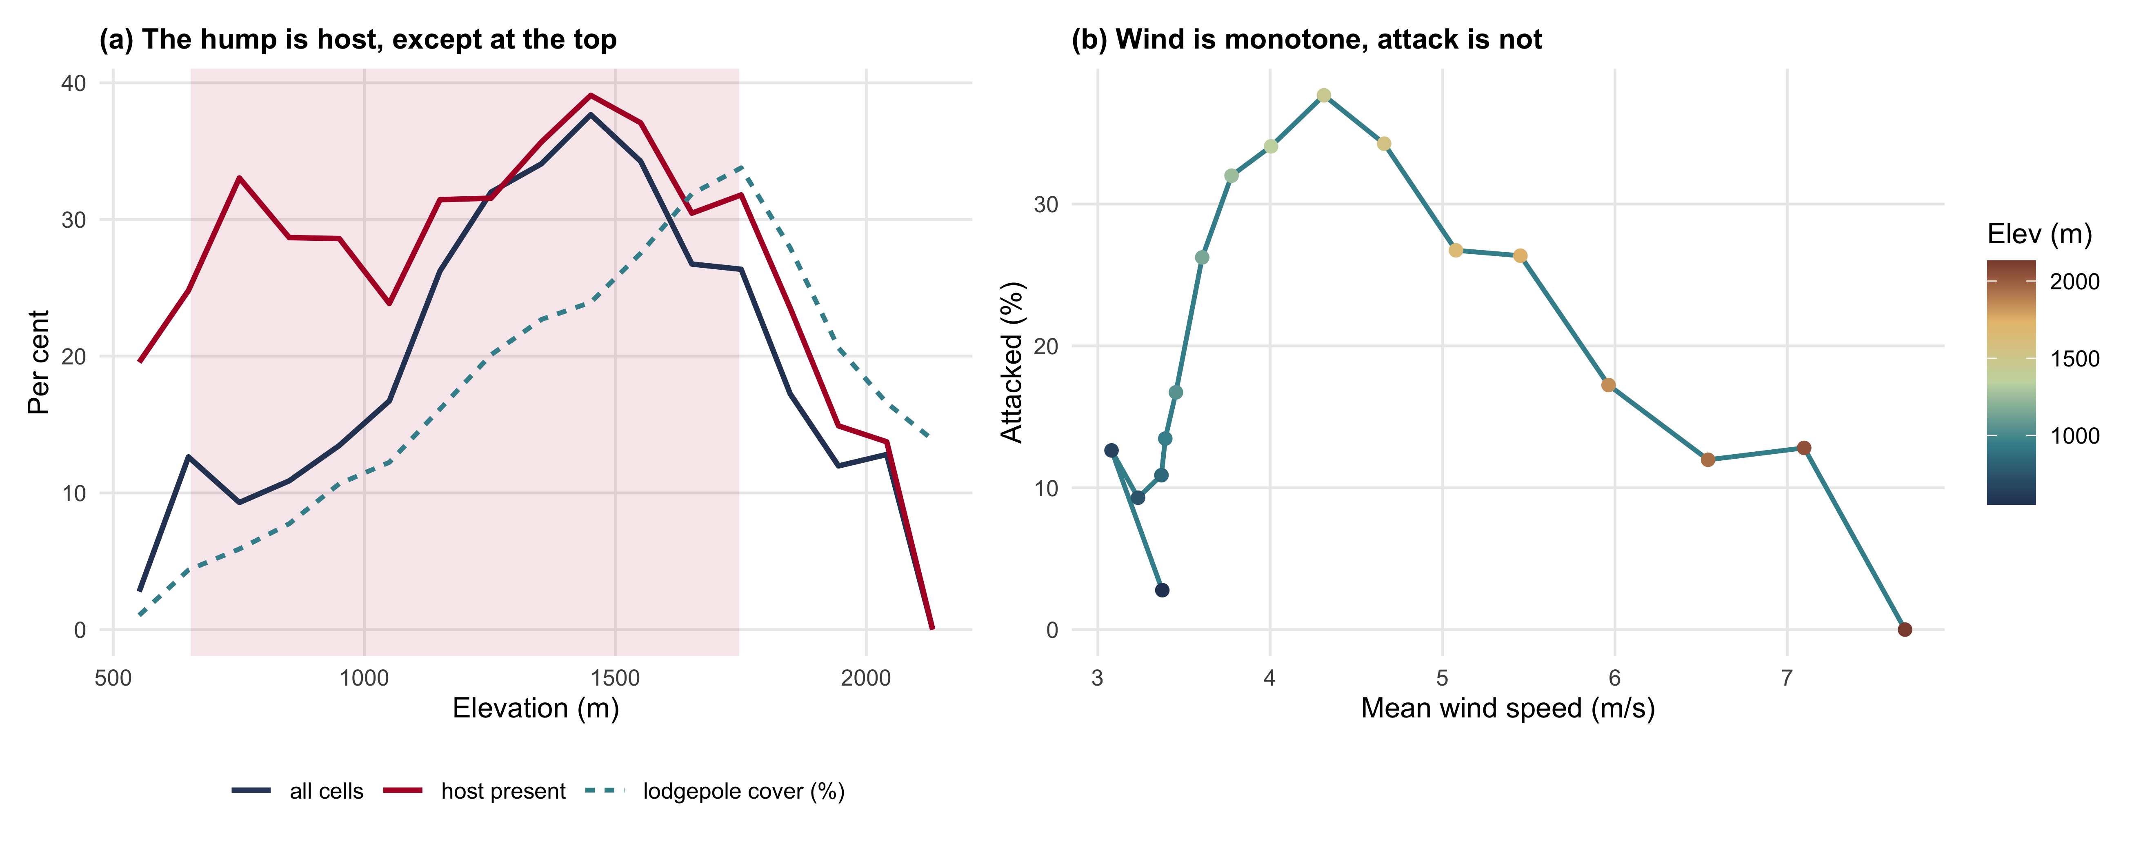
Figure 3: (a) Attack across the gradient, raw and conditioned on lodgepole presence, with mean lodgepole cover. (b) The same data against wind speed: wind rises monotonically with elevation while attack turns over, so no monotone wind relationship can hold across the gradient. Shading marks the elevation range of the 2 by 4 km clip.

4.2 The Krawchuk test
Restricted to cells containing host, the orthogonalised wind term is the largest negative coefficient in the model, -0.176 per standard deviation, comparable to the positive effect of lodgepole cover at +0.177 (Table S1). Its sign is reproduced in 95 per cent of block resamples, but its 95 per cent block interval runs [-0.390, +0.037] and reaches zero.
On this fit the hypothesis is supported in direction and unresolved in magnitude, and Section 4.4 later withdraws even the direction, so read this section as the conventional analysis whose specification we go on to test rather than a result we stand behind. The descriptive result in Section 4.1 is not in doubt: attack more than halves at the top of the gradient while host cover thins only slightly. What is in doubt is whether wind is the right explanation, and with roughly 175 independent 1 km blocks the binary response cannot settle it. Host cover is the only term whose interval excludes zero.
That verdict is a property of the response coding rather than of the data, and Section 4.3 revisits it. We report the binary model first because it is the form the refugia literature uses, and the comparison is itself a result.
Elevation, entered alongside the orthogonalised wind term, is itself negative and unsupported: once host is in the model the remaining elevation signal is weak, so the suppression at the top is not simply an elevation effect.

4.3 Disturbance severity metrics
Table 4: Cumulative logits at each severity threshold, cells containing lodgepole pine only. The orthogonalised wind coefficient strengthens monotonically as the threshold rises and its block interval excludes zero above trace, which the binary model does not show.
Threshold | Cells | Wind resid ^{B} | block 95% CI | Sign stability | Pine cover ^{B} | Supported
trace or worse | 38,473 | -0.176 | [-0.390, +0.037] | 0.95 | +0.177 | no
light or worse | 34,839 | -0.203 | [-0.418, -0.015] | 0.98 | +0.204 | yes
moderate or worse | 13,862 | -0.390 | [-0.674, -0.066] | 0.99 | +0.243 | yes
severe or worse | 1,522 | -1.002 | [-1.552, -0.169] | 0.98 | -0.101 | yes

Collapsing the response to attacked or not costs the study its main result. Fitted at successively harder severity thresholds, the orthogonalised wind coefficient strengthens monotonically from -0.176 at trace or worse to -1.002 at severe or worse, a 5.7-fold increase (Table 4). At every threshold above trace the block interval excludes zero. The first row is the binary model of Section 4.2 restated, since a cell reaching trace or worse is exactly a cell recorded as attacked, so the table extends that fit rather than competing with it. It is also the weakest of the four, and the one the refugia literature would conventionally have reported.
This is a dose-response gradient of the shape the hypothesis predicts. Wherever the wind surface has a component independent of elevation, that component is associated with less attack, and the association is strongest where attack was heaviest. It also explains the binary result: a cell that reached trace severity is barely distinguishable from an unattacked cell, so a threshold drawn between them puts most of the noise exactly where the model is asked to fit.
The slopes differ by a factor of 5.7 across the thresholds, so proportional odds does not hold and a single ordinal coefficient would be the wrong summary. Fitting one anyway returns -0.207, close to the trace-threshold estimate and concealing everything above it. Two other terms move with the threshold. Lodgepole cover, the only term that cleared the interval test in the binary model, weakens as the threshold rises and reverses at severe or worse (-0.101). One reading is ecological: host abundance governs whether a stand is attacked at all, not how hard. A second is an artefact of the inventory’s vintage, and we cannot separate them. Composition was interpreted from 2014 photography, late in the outbreak window, so stands that lost their pine early carry a lower recorded lodgepole percentage than when the beetle reached them. That predicts a negative coefficient at the heaviest severities, which is what is observed. We report the reversal and decline to interpret it. Elevation turns positive at moderate or worse (+0.390), consistent with severe attack having concentrated in the mid-elevation pine belt rather than at either end.
We cannot attribute the gradient to wind rather than cold, and the Discussion explains why the ordinal result does not help. More seriously, Section 4.4 shows the sweep does not survive entering elevation flexibly, so what looks here like improved support is largely the unimodal elevation response returning through a predictor orthogonalised only against the linear part of elevation. Read this table together with that one.

4.4 Wind effects by elevation
Table 5: The ordinal sweep refitted with elevation entered flexibly instead of linearly, and wind residualised against that same basis. Elevation explains eleven points more of the wind surface once curvature is allowed, and no threshold clears the interval test under either flexible basis.
Elevation basis | R² wind on basis | Threshold | Wind residual beta | block 95% CI | Supported
linear | 0.617 | trace or worse | -0.176 | [-0.390, +0.037] | no
linear | 0.617 | light or worse | -0.203 | [-0.418, -0.015] | yes
linear | 0.617 | moderate or worse | -0.390 | [-0.674, -0.066] | yes
linear | 0.617 | severe or worse | -1.002 | [-1.552, -0.169] | yes
quad | 0.726 | trace or worse | -0.051 | [-0.261, +0.158] | no
quad | 0.726 | light or worse | -0.075 | [-0.254, +0.085] | no
quad | 0.726 | moderate or worse | -0.160 | [-0.445, +0.156] | no
quad | 0.726 | severe or worse | -0.661 | [-1.139, +0.237] | no
spline | 0.728 | trace or worse | -0.064 | [-0.270, +0.146] | no
spline | 0.728 | light or worse | -0.090 | [-0.266, +0.059] | no
spline | 0.728 | moderate or worse | -0.163 | [-0.439, +0.161] | no
spline | 0.728 | severe or worse | -0.676 | [-1.169, +0.222] | no

Sandel (2015) gives the diagnostic that motivates this test. For a genuinely linear relationship a coefficient is extent-independent and only the coefficient of determination moves as extent changes; a coefficient that changes sign under truncation is a symptom of an unmodelled nonlinearity rather than a general law of extent. Our response is unimodal in elevation and our wind surface monotone in it, exactly the configuration that produces such a symptom, so the specification has to be tested rather than assumed.
It does not pass. Entering elevation as a quadratic raises the share of the wind surface that elevation explains from 0.617 to 0.726, and a natural spline on four degrees of freedom raises it to 0.728. Roughly eleven percentage points of the wind surface’s variance is therefore nonlinear in elevation, and the linear orthogonalisation used above leaves all of it inside what we had been calling the component of wind independent of elevation.
When that residue is removed the wind result goes with it. The coefficient at severe or worse falls from -1.002 to -0.661, and at moderate or worse from -0.390 to -0.160, losing between three fifths and seven tenths of its magnitude. Under both flexible bases every interval covers zero at every threshold. The monotone strengthening across thresholds survives in the point estimates, but nothing in the sweep clears the test this paper set itself.
We report this as the result rather than relegating it to a sensitivity appendix, because it changes what the preceding two sections mean. The dose-response in Table 4 is not evidence about wind. It is very largely the unimodal elevation response reappearing through a predictor that was never orthogonal to the curvature of elevation, only to its slope. This study does not have a wind effect to report, and the appearance of one followed from how elevation was specified.

4.5 Thermal load by aspect
Table 6: The host-present model with the two aspect-derived terms added, at each threshold it can carry. Heat load is positive and strengthens sharply with severity: warmer aspects burn harder at the same elevation. The orthogonalised wind term is not displaced by it. The shelter index points the other way, which the text takes seriously rather than explaining away.
Threshold | Cells | Wind residual | Heat load | Shelter
trace or worse | 38,473 | -0.214 [-0.424, +0.002] | +0.106 [-0.116, +0.331] | -0.153 [-0.253, -0.024]
light or worse | 34,839 | -0.234 [-0.441, -0.050] | +0.043 [-0.198, +0.274] | -0.152 [-0.262, -0.031]
moderate or worse | 13,862 | -0.505 [-0.804, -0.184] | +0.625 [+0.301, +1.030] | -0.013 [-0.144, +0.131]

The inherited predictor set had no aspect, so until now the model could not tell a warm slope from a cold one at the same elevation. Adding two aspect-derived terms does three things.
First, it supplies the one piece of thermal information available without a temperature surface. Heat load is positive at every threshold and strengthens steeply with severity (Table 6). Since heat load is essentially uncorrelated with elevation (Table 2), this is not the elevation gradient under another name: at a given elevation, southwest-facing ground carries heavier mortality than northeast-facing ground. That is the sign cold limitation predicts, and the first evidence here that the thermal axis works independently of elevation.
Second, it leaves the wind coefficient standing. The orthogonalised wind term does not weaken when heat load is controlled for, so whatever it tracks is not the warm-aspect effect in disguise. It is, however, largely the curvature of elevation: this model still enters elevation linearly, and Section 4.4 shows the wind term does not survive a flexible basis. Controlling for aspect does not rescue it.
Third, and least comfortably, the two exposure measures disagree. The shelter index is negative, meaning sheltered ground carries less attack and exposed ground more, the opposite of what the orthogonalised wind term says and of what Krawchuk et al. (2020) predict. The two are only weakly correlated (-0.22), so they are not two measurements of one quantity that happen to disagree; they measure different things, and only one is a direct geometric description of exposure. We take this as evidence against treating any single surface as “wind exposure” and reporting its coefficient as though the phrase had one referent. It is also a caution against our own result: the wind residual’s negative sign is not corroborated by the one predictor here that describes exposure geometrically rather than by downscaling.
The severe threshold is absent from Table 6 because ten terms and 1522 events drive the fit into quasi-separation, with 14,466 cells at numerically zero fitted probability. The eight-term model of Table 4 is free of this, which is why it retains its severe row and this one does not.

4.6 Winter temperature thresholds
Table S2 summarises the record and Figure S2 maps the network. No station lies inside the analysis grid, and the stations reaching the coldest minima are not the highest ones, which is the point the next paragraph develops.
The cold explanation for the high-elevation suppression assumes it gets cold enough up there to kill beetles. It does not hold. Across 347 station-winters from 28 stations spanning 435 to 2423 m, retrieved and screened for the coldest defensible winter minimum anywhere in the region is -28.7 °C, at norns at 2,423 m in winter 2014. The number of station-winters reaching -35 °C or colder is 0, and the number reaching -40 °C or colder is 0. Above 1,500 m the mean winter minimum is -19.4 °C. The temperatures conventionally cited as lethal for larvae sit near -40 °C under bark, the figure at which Safranyik and Wilson (2006) report complete mortality, while Cooke (2009) measure a median lethal supercooling point near -37 °C and caution against any fixed threshold. Both are roughly ten degrees colder than anything this record contains. Neither is an air temperature, but phloem tracks air within about two degrees, so the comparison holds; and cold mortality is graded rather than a threshold, so this is a margin against substantial mortality rather than a guarantee of none.
Two features of the record matter. Elevation orders these minima only weakly: grand forks, at 630 m, reaches -28.2 °C, within 0.5 °C of the alpine station 1,793 m higher. That is cold-air pooling, and the reason temperature cannot be treated as a linear function of elevation here. And 16 station-winters were set aside because the sensors floor at exactly -20.0 °C, an artefact concentrated before 2008; a naive minimum over those would have manufactured a threshold that is not in the data.
This is a plausibility check, not a temperature surface. No station inside the study area reported during the outbreak window, and those that do are spread across roughly 100 km of separate massifs, so these values bound the regional cold climate rather than map it. Within that limit the conclusion is firm enough: direct freeze mortality is unlikely to be what suppresses attack at the top of this gradient.

4.7 Area extents of coefficients
Table 7: The same model fitted at three extents. As the analysis area shrinks, the share of wind variance explained by elevation rises and the orthogonalised wind coefficient reverses sign. The 2 by 4 km clip is the extent at which the companion study was run.
Scale | Cells | Blocks | R² Wind-Elev | Wind VIF | Wind resid ^{B} | block 95% CI
landscape (168 km²) | 266,650 | 253 | 0.629 | 2.7 | -0.304 | [-0.521, -0.098]
Landscape (host stand) | 127,604 | 175 | 0.617 | 2.6 | -0.176 | [-0.390, +0.037]
landscape (6.2 km²) | 9,784 | 15 | 0.797 | 4.9 | +0.239 | [-1.260, +0.921]

The confound is a function of extent, and so is the answer. Across the landscape, elevation explains 63 per cent of the variance in the wind surface; inside the 2 by 4 km clip it explains 80 per cent (Table 7). The orthogonalised wind coefficient is negative at landscape extent and positive inside the clip.
Two claims live in that table and carry very different weight.
The collinearity result is firm. The share of wind variance elevation explains rises from 0.629 across the landscape to 0.797 inside the clip, and that quantity is a property of the two surfaces rather than an estimate with sampling error. It is the mechanism this paper is about, and does not depend on resolving the Krawchuk hypothesis.
The sign reversal is a comparison of two point estimates and is not, on this evidence, a demonstrated reversal. The clip contains only 15 spatial blocks, so its block interval runs [-1.260, +0.921]: it spans zero, and it spans both landscape estimates. By the rule this paper set itself the clip coefficient is not distinguishable from zero, from the landscape estimate, or from its own opposite. What the clip demonstrates is that shrinking the extent destroys the ability to estimate the coefficient at all, a weaker claim than reversal and still damaging for the practice we criticise: a study at this extent would report a positive point estimate with an interval too wide to notice it had learned nothing. Establishing reversal proper would need an extent-by-wind interaction fitted on the pooled data and bootstrapped on common blocks. We have not done that and do not claim it.

4.8 Grain effects on coefficients
Work et al. (2011), working on carabid beetles, found the apparent importance of terrain derivatives changed with the resolution at which they were computed, because elevation error propagates into derived curvature differently at every grain. The concern transfers directly and is worth separating from extent, which is routinely confused with it.
Here they behave quite differently (Table S3). Aggregating from 25 m to 100 m, a sixteen-fold reduction in cells, leaves the confound essentially untouched: elevation explains close to the same share of wind variance at every grain, and the orthogonalised wind coefficient neither reverses nor decays. The suppression at the top of the gradient is a landscape-scale feature and survives a coarser lens.
The contrast with Section 4.7 is the point, and one we should not overstate. Enlarging the cell fourfold changes almost nothing; shrinking the study area destroys the estimate. Grain governs how finely a pattern is resolved, extent governs which part of the joint distribution of elevation and wind the model ever sees, and here only the second mattered.
That is a result about this landscape and this pair of surfaces, not a general ordering of the two axes. Wiens (1989) set out the distinction and warned that correlations evident within one domain may disappear or change sign when the extent is enlarged past it, and Dungan et al. (2002) recommended that studies report unit size, shape, spacing and extent together for the same reason. The literature since has not settled which axis matters more, and where it has looked it has often found the opposite of what we find: McGarigal et al. (2016), reviewing several hundred multi-scale habitat studies, concluded that the emphasis on extent may have left grain under-examined. Nor is reporting the weak point we assumed: Estes et al. (2018) found resolution and extent reported at closely comparable rates, near three fifths in both cases.
What our result adds is narrower and more useful. Sandel (2015) shows that for a genuinely linear relationship the coefficient is extent-independent and only the coefficient of determination moves with extent. A coefficient that changes sign under truncation is therefore a diagnostic for an unmodelled nonlinearity rather than an instance of a general law. That is very likely what is happening here: Figure 3 shows attack unimodal in elevation while wind rises monotonically, so no monotone wind term can hold across the whole gradient, and the clip lands on one limb of the hump. Read that way the finding is not “extent reverses inferences” but the sharper “truncating a gradient onto one limb of a unimodal response will reverse the apparent sign of anything monotonically correlated with the gradient.” Testing it properly means fitting the nonlinearity rather than assuming it away, which is the first thing we would do next.

5. Discussion
The high-elevation suppression is real and it is not host limitation. Among cells carrying lodgepole pine, attack above 1,900 m runs at 13.7 per cent against 31.5 per cent below, while mean pine cover there is 21 per cent lower than in the band immediately below and basal area roughly a fifth lower, so the fall in attack is several times larger than the fall in host. Under the Krawchuk et al. (2020) definition these are refugia: disturbed less severely than the surrounding landscape, with host present, and predictably located by an enduring topographic feature, matching Cartwright (2018) in associating refugia with thinner stands.
What we cannot do is attribute them to wind. The ordinal result in Section 4.3 changes one half of that difficulty and leaves the other where it was.
The statistical half looked, at first, much improved. Once severity is modelled as the ordinal variable it is, the orthogonalised wind term clears the interval test at every threshold above trace and strengthens monotonically with severity. Section 4.4 withdraws that reading. Entering elevation flexibly, and residualising wind against the same basis rather than against a straight line, removes between three fifths and seven tenths of the coefficient and leaves no threshold clearing the test. The ordinal coding does recover structure the binary discards, and Krawchuk et al. (2020)’s warning against binary refugia coding stands. But that structure is not attributable to wind: it is very largely the curvature of the elevation response, which the linear specification pushed into the wind term. We therefore do not report a wind effect, in either coding.
The identification half is untouched. The upper gradient is also where it is coldest, and cold limits this beetle through overwinter mortality and through the degree-day accumulation univoltine development requires (Carroll and Safranyik 2004; Safranyik and Wilson 2006; Cooke 2009). Cold predicts a dose-response in severity just as wind disruption does: fewer beetles surviving winter means both fewer stands attacked and lighter attack in those that are. The monotone strengthening across thresholds is therefore fully consistent with cold limitation and does nothing to separate the two. Orthogonalising against elevation does not orthogonalise against temperature, which is not a linear function of elevation where cold air pools.
We looked for a way out and do not think one exists at this extent. Separating exposure from cold needs a temperature surface whose fine-scale structure is not itself a function of the elevation model, and any surface of the form intercept plus lapse rate times elevation is an affine rescaling of the elevation layer, whatever the lapse rate’s source. It is collinear by construction, and only a residual departure from that form would identify anything, which would itself require terrain as the interpolator. The gridded products with genuine sub-kilometre temperature structure all obtain it by regression onto a digital elevation model, so they reproduce the problem rather than solve it.
Two results bear on this. The first is that cold limitation here is almost certainly not freeze mortality. Section 4.6 shows observed winter minima across the region fall roughly 11 degrees short of the temperatures conventionally cited as lethal for this insect, at every elevation for which there is a record. If larvae are not killed outright, the mechanism that remains is the degree-day accumulation needed to complete a generation in one year.
The second is that aspect gives purchase on exactly that. Because heat load is a trigonometric function of the elevation model rather than a field draped over it, it carries thermal information independent of elevation, and Section 4.5 finds it predicts attack severity in the direction warmth-limited development implies. The thermal constraint that plausibly operates here is the one for which we have an elevation-independent proxy, and that proxy behaves as the constraint predicts.
This gain is bounded in three ways. The station record is a regional plausibility check, not a temperature surface, since no station inside the study area reported during the outbreak window. Heat load is a modelled radiation load, not a measured temperature. And neither touches the possibility that cold-air pooling produces local freeze events the station network never sampled, which is precisely the structure Section 4.6 shows when a valley station at 630 m matches an alpine station 1,793 m above it.
The deeper obstacle is that the quantity governing overwinter survival is not air temperature but temperature under the bark, which is not observed at landscape scale anywhere. Goodsman et al. (2024), validating the standard Canadian Forest Service winter mortality model against observed mortality in Banff National Park, found its spatial predictions poor and attributed the failure to precisely this. The confound we report unresolved is unresolved in this terrain generally, and not an artefact of our data being thin.
There is also a class of mechanism that would produce our result without pheromone plumes at all. If exposed ground receives fewer arriving beetles, rather than the same number arriving to a disrupted signal, the observable consequence in a static model is identical: less attack on exposed convexities. We advance that as an alternative of our own, because the obvious precedent does not support it. Smith-McKenna et al. (2013), working on white pine blister rust in whitebark pine treeline communities, established that topographic position governs delivery of a wind-borne propagule; but the direction they report is the opposite of the one this alternative needs, with exposed positions favouring interception rather than escape. Their agent is a fungus dispersed passively, so neither direction transfers cleanly to a flying insect that selects where it lands. What their result does establish is that the dispersal pathway is a live confound in terrain of this kind. Nothing in our design distinguishes it from pheromone disruption; doing so would need the dispersal process observed rather than inferred, through attack years, distance from the previous year’s attack, or trapping.
The honest summary is that we have located candidate refugia and confirmed the host-density half of the hypothesis, but cannot support the wind half once elevation is fitted flexibly, and the mechanism remains confounded with at least two alternatives on the same gradient.

5.1 Lower elevation effects
The result that should travel furthest is at the bottom of the gradient. Attack there is near zero, and any refugia mapping exercise lacking a host layer would have identified the valley as a large, spatially coherent, topographically predictable refugium. It is not a refugium. It is a place with almost no pine. Conditioning on host raises attack in the lowest band from 6.5 per cent to 23.3 per cent, which is within the range observed at mid elevations.
Krawchuk et al. (2020) anticipate this in framing, asking of any candidate refugium both what it is a refugium from and what it is a refugium for, but the framework does not force the check and the data required to perform it are not always at hand. On this landscape the difference between performing it and not is the difference between reporting a roughly 42 km2 valley refugium, the modelled ground below 900 m that Table 3 shows carries almost no pine, and reporting none. We would put the requirement more strongly than the framework currently does: a refugium claim without an independent host or habitat layer is not interpretable.

5.2 Limits to terrain predictors
The collinearity result in Section 4.7 generalises beyond wind. A fine-resolution climate surface is produced by imposing terrain on a coarse field, so wherever the coarse field is nearly constant the product approaches a function of the terrain. That covers most gridded climate products used in landscape ecology. Three properties govern the severity, and all are checkable before any model is fitted: the ratio of analysis extent to the correlation length of the driving field, the relief of the study area, and which terrain variable does the work in the downscaling, which for wind is elevation and roughness but for radiation would be slope and aspect.
The consequence for synthesis is uncomfortable. If a confound scales with study extent, effect sizes for derived climate predictors are not comparable across studies of different extents, and small studies will systematically report the strongest apparent effects, a pattern easily mistaken for publication bias.
We would ask three things of any study entering such a surface into a disturbance model: report its regression on elevation, report the same diagnostic at more than one extent, and interpret only the orthogonalised coefficient. None requires new data, and here each changed the answer.
The plot record calibrates severity but not location, because coordinates for the 28 ground plots were not recoverable. The survey response is observer sketch-mapping with known positional and severity error, and rasterising polygons imposes a grain coarser than the 25 m cell; severity classes are assigned by eye from an aircraft, so the ordinal gradient in Section 4.3 rests on judgement of proportion killed rather than measurement. The inventory is a modelled operational product whose species percentages are polygon-level attributes applied uniformly. The grain test in Section 4.8 spans 25 m to 100 m, which brackets the resolutions in common use and the 900 m2 Landsat grain at which Krawchuk et al. (2020) note refugia have typically been described. Finally the analysis is correlational and the outbreak is one epidemic passage; frequency refugia in the sense of Krawchuk et al. (2020) cannot be addressed with a single window, and the static design cannot separate a wind effect on pheromone communication from one on dispersal.
The identification gained in Section 4.5 is partial. Heat load bears on the degree-day half of cold limitation, the half governing whether a generation completes in one year. It says almost nothing about the overwinter minimum half, the lethal events that kill larvae outright, which are driven by synoptic air mass intrusions and cold-air pooling rather than by radiation on a slope. Separating warm aspects from cool ones at the same elevation therefore addresses one thermal mechanism and leaves the other untouched, and rests on an assumed functional form, the McCune and Keon (2002) equation, rather than an independent measurement.
The shelter index is also imperfect as a test of the mechanism. It is omnidirectional because the Global Wind Atlas supplies no direction, and an omnidirectional index cannot represent a process that depends on where the wind comes from. A directional index on a known prevailing bearing would be sharper, and its disagreement with the wind residual might resolve either way under one.

6. Conclusions
Beetle-caused mortality at Darkwoods is unimodal across the 1,740 m of relief the modelled area spans. Below 1,900 m that pattern is the distribution of lodgepole pine, and conditioning on host removes almost all of it. Above 1,900 m it is not: attack more than halves while host cover thins only slightly, so the decline is far larger than a proportionate response to the decline in host. That is where the Krawchuk hypothesis predicts refugia should be.
We do not find a wind effect. The component of the Global Wind Atlas surface orthogonal to a linear elevation term is the strongest negative predictor of attack in host-bearing stands, and modelled as the ordinal severity class it clears the interval test at every threshold above trace. But the response is unimodal, and orthogonalising against a straight line leaves the curvature of elevation inside the wind term. Entering elevation as a quadratic or a spline, and residualising wind against that same basis, collapses the coefficient at every threshold. The apparent wind signal is a specification artefact. Even had it survived, attribution would have remained open, because cold limitation and dispersal interception both predict the same gradient.
Two further results narrow that gap without closing it. Observed winter minima from every station within 100 km fall about ten degrees short of the temperatures conventionally cited as lethal, so the cold mechanism that plausibly operates here is the accumulated warmth a generation needs, not freeze mortality. And a heat load index, a trigonometric function of the elevation model and therefore almost unrelated to elevation, predicts attack at the moderate severity threshold in the direction cold limitation implies, though not at the two lighter thresholds, so the thermal axis is doing work that is not the elevation gradient under another name. But a geometric shelter index computed from the same elevation model carries the opposite sign to the wind residual while being nearly uncorrelated with it, a warning that “wind exposure” is not one measurable thing and that our wind result lacks corroboration from the one predictor describing exposure directly.
The methodological findings are firmer, and all three are failures of design rather than data. Fitted inside a 2 by 4 km clip of the same landscape, elevation explains four fifths of the variance in the wind surface rather than two thirds, the wind coefficient’s point estimate turns positive, and its interval widens until it excludes nothing; a four-fold change of grain moves none of this. Extent is the axis that governs whether the coefficient can be estimated here. We do not generalise that ordering: following Sandel (2015), the likeliest reading is that truncating a gradient onto one limb of a unimodal response reverses the apparent sign of anything monotonically correlated with it, which is a statement about functional form rather than extent as such. Collapsing severity to attacked or not converts the study’s strongest apparent relationship into a null. And without a host layer, the pine-poor valley floor would have been mapped as the largest refugium on the mountain.

7. CRediT authorship declaration
Seamus Murphy: Conceptualization, Methodology, Software, Formal analysis, Investigation, Data curation, Writing - original draft, Writing - review & editing, Visualization.

8. Competing interest declaration
The author declares no known competing financial interests or personal relationships that could have appeared to influence the work reported in this paper.

9. Funding declaration
This research received no specific grant from any funding agency in the public, commercial or not-for-profit sectors.

10. Declaration of Generative AI
All prose, writing, results in the analysis and reporting contained within this document was derived and verified by the author. No generative tool was used to create, alter or manipulate research data or results. The author is responsible for the accuracy of all content.

11. Data availability
Every dataset used here is public and none was collected by the author. Beetle-caused mortality is the British Columbia Aerial Overview Survey pest infestation polygon layer, filtered to IBM for 1999 to 2015. Host cover and stand basal area are the provincial Vegetation Resources Inventory layer VEG_COMP_LYR_R1_POLY, retrieved from the British Columbia Data Catalogue web feature service. Ambient wind is Global Wind Atlas mean speed at 10 m (Technical University of Denmark). Terrain is derived from the Natural Resources Canada High Resolution Digital Elevation Model (Natural Resources Canada 2017). Winter minima are British Columbia Wildfire Service hourly and Environment and Climate Change Canada daily records for stations within 100 km, retrieved by the script stored in the study’s data repository. To ensure reproducibility, all scripts along with input materials, analysis code, and runtime settings were stored in the following github address ready for cloning to local environments: https://github.com/seamusrobertmurphy/beetle-topography-and-wind-study. The analysis code is rendered in within manuscript’s markdown and can be run in over one iteration, so that rendering re-runs the pipeline and regenerates the results.

12. Ethics declarations
This study analysed publicly available spatial and meteorological records only. It involved no human participants, no animal subjects and no sampling of protected species, so ethics approval and informed consent were not required.

13. Word counts
Total including references, 10,711. Total excluding references, 9,815. Abstract, 27. Supplementary information, 0.

14. References
Badger J, Frank H, Hahmann AN, Giebel G (2014) Wind-climate estimation based on mesoscale and microscale modeling: Statistical–dynamical downscaling for wind energy applications. Journal of Applied Meteorology and Climatology 53:1901–1919. https://doi.org/10.1175/JAMC-D-13-0147.1
Beers TW, Miller CI (1973) Manual of forest mensuration. T and C Enterprises, West Lafayette, Indiana
Braumandl TF, Dykstra PR (2005) A field guide for site identification and interpretation for the Nelson Forest Region: Supplement 1. British Columbia Ministry of Forests and Range, Forest Science Program, Victoria, British Columbia
Carroll AL, Safranyik L (2004) The bionomics of the mountain pine beetle in lodgepole pine forests: Establishing a context. In: Shore TL, Brooks JE, Stone JE (eds) Mountain pine beetle symposium: Challenges and solutions, october 30–31, 2003, kelowna, british columbia. Natural Resources Canada, Canadian Forest Service, Pacific Forestry Centre, Victoria, British Columbia, pp 21–32
Cartwright JM (2018) Landscape topoedaphic features create refugia from drought and insect disturbance in a lodgepole and whitebark pine forest. Forests 9:715. https://doi.org/10.3390/f9110715
Cooke BJ (2009) Forecasting mountain pine beetle overwintering mortality in a variable environment. Natural Resources Canada, Canadian Forest Service, Pacific Forestry Centre, Victoria, British Columbia
Davis NN, Badger J, Hahmann AN, et al (2023) The Global Wind Atlas: A high-resolution dataset of climatologies and associated web-based application. Bulletin of the American Meteorological Society 104:E1507–E1525. https://doi.org/10.1175/BAMS-D-21-0075.1
Dungan JL, Perry JN, Dale MRT, et al (2002) A balanced view of scale in spatial statistical analysis. Ecography 25:626–640. https://doi.org/10.1034/j.1600-0587.2002.250510.x
Estes L, Elsen PR, Treuer T, et al (2018) The spatial and temporal domains of modern ecology. Nature Ecology & Evolution 2:819–826. https://doi.org/10.1038/s41559-018-0524-4
Goodsman DW, Weber JD, Bleiker KP (2024) An evaluation of a winter mortality model for the mountain pine beetle. Forests 15:1425. https://doi.org/10.3390/f15081425
Gray B, Billings RF, Gara RI, Johnsey RL (1972) On the emergence and initial flight behaviour of the mountain pine beetle, Dendroctonus ponderosae, in eastern Washington. Zeitschrift für angewandte Entomologie 71:250–259. https://doi.org/10.1111/j.1439-0418.1972.tb01745.x
Hadley KS (1994) The role of disturbance, topography, and forest structure in the development of a montane forest landscape. Bulletin of the Torrey Botanical Club 121:47–61. https://doi.org/10.2307/2996883
Jones KL, Shegelski VA, Marculis NG, et al (2019) Factors influencing dispersal by flight in bark beetles (Coleoptera: Curculionidae: Scolytinae): From genes to landscapes. Canadian Journal of Forest Research 49:1024–1041. https://doi.org/10.1139/cjfr-2018-0304
Ketcheson MV, Braumandl TF, Meidinger D, et al (1991) Interior Cedar – Hemlock Zone. In: Meidinger DV, Pojar J (eds) Ecosystems of British Columbia. Research Branch, British Columbia Ministry of Forests, Victoria, British Columbia, pp 167–181
Krawchuk, M. A., Meigs, G. W., Naficy, C. E., Bell, D. M., Hudec, J. L., Rockweit, J. T., & Davis, R. J. (2026). Fire refugia in forest ecosystems of the Pacific Northwest, USA: Science and applications for conservation, adaptation, and stewardship. Conservation Science and Practice, 8(1), e70173.
Krawchuk MA, Meigs GW, Cartwright JM, et al (2020) Disturbance refugia within mosaics of forest fire, drought, and insect outbreaks. Frontiers in Ecology and the Environment 18:235–244. https://doi.org/10.1002/fee.2190
McCune B, Keon D (2002) Equations for potential annual direct incident radiation and heat load. Journal of Vegetation Science 13:603–606. https://doi.org/10.1111/j.1654-1103.2002.tb02087.x
McGarigal K, Wan HY, Zeller KA, et al (2016) Multi-scale habitat selection modeling: A review and outlook. Landscape Ecology 31:1161–1175. https://doi.org/10.1007/s10980-016-0374-x
Meddens AJH, Hicke JA, Vierling LA, Hudak AT (2013) Evaluating methods to detect bark beetle-caused tree mortality using single-date and multi-date Landsat imagery. Remote Sensing of Environment 132:49–58. https://doi.org/10.1016/j.rse.2013.01.002
Murphy S, Leslie A, Wilson J, Banks LK (2026) Spatial patterns of conifer regeneration following mountain pine beetle outbreak (Dendroctonus ponderosae) and mixed-severity wildfire: A point process model of disturbance interactions in the southern Selkirk Mountains, British Columbia. Forest Ecology and Management 618:123985. https://doi.org/10.1016/j.foreco.2026.123985
Natural Resources Canada (2017) High resolution digital elevation model (HRDEM) – CanElevation series. https://open.canada.ca/data/en/dataset/957782bf-847c-4644-a757-e383c0057995
Parker AJ (1982) The topographic relative moisture index: An approach to soil-moisture assessment in mountain terrain. Physical Geography 3:160–168. https://doi.org/10.1080/02723646.1982.10642224
Safranyik L, Wilson B (eds) (2006) The mountain pine beetle: A synthesis of biology, management, and impacts on lodgepole pine. Natural Resources Canada, Canadian Forest Service, Pacific Forestry Centre, Victoria, British Columbia
Sandel B (2015) Towards a taxonomy of spatial scale-dependence. Ecography 38:358–369. https://doi.org/10.1111/ecog.01034
Smith-McKenna EK, Resler LM, Tomback DF, et al (2013) Topographic influences on the distribution of white pine blister rust in Pinus albicaulis treeline communities. Écoscience 20:215–229. https://doi.org/10.2980/20-3-3599
Technical University of Denmark Global wind atlas: Mean wind speed at 10 m above ground level. https://globalwindatlas.info
Wang L, Liu H (2006) An efficient method for identifying and filling surface depressions in digital elevation models for hydrologic analysis and modelling. International Journal of Geographical Information Science 20:193–213. https://doi.org/10.1080/13658810500433453
White JC, Wulder MA, Brooks D, et al (2005) Detection of red attack stage mountain pine beetle infestation with high spatial resolution satellite imagery. Remote Sensing of Environment 96:340–351. https://doi.org/10.1016/j.rse.2005.03.007
Wiens JA (1989) Spatial scaling in ecology. Functional Ecology 3:385–397. https://doi.org/10.2307/2389612
Winstral A, Elder K, Davis RE (2002) Spatial snow modeling of wind-redistributed snow using terrain-based parameters. Journal of Hydrometeorology 3:524–538. https://doi.org/10.1175/1525-7541(2002)003<0524:SSMOWR>2.0.CO;2
Work TT, St. Onge B, Jacobs JM (2011) Response of female beetles to LIDAR derived topographic variables in Eastern boreal mixedwood forests (Coleoptera, Carabidae). ZooKeys 147:623–639. https://doi.org/10.3897/zookeys.147.2013
Ye S, Rogan J, Zhu Z, et al (2021) Detecting subtle change from dense Landsat time series: Case studies of mountain pine beetle and spruce beetle disturbance. Remote Sensing of Environment 263:112560. https://doi.org/10.1016/j.rse.2021.112560

15. Supplementary information
The five items below are cited in the main text as Tables S1 to S3 and Figures S1 and S2. They are supplied as supplementary material and are not counted toward the ten figures and tables the main text carries. Each is produced by code already run above, so the values are identical to those the main text quotes.
Table S1. The binary hypothesis test, cells containing lodgepole pine only. Coefficients are per standard deviation; wind is entered as the component orthogonal to elevation. Intervals are percentile intervals from resampled 1 km spatial blocks. This is the same fit as the first row of the ordinal sweep in the main text, retained because it is the form the refugia literature conventionally reports.
Term | beta | naive z | block 95% CI | sign stability | Supported
Elevation | -0.130 | -19.2 | [-0.396, +0.172] | 0.83 | no
WindResid | -0.176 | -26.8 | [-0.390, +0.037] | 0.95 | no
PinePct | +0.177 | +28.0 | [+0.046, +0.319] | 1.00 | yes
Basal | +0.028 | +4.3 | [-0.171, +0.199] | 0.65 | no
TPI600 | +0.002 | +0.4 | [-0.097, +0.111] | 0.53 | no
Slope | +0.004 | +0.5 | [-0.148, +0.152] | 0.50 | no
TWI | -0.010 | -1.5 | [-0.094, +0.050] | 0.61 | no
RIX | -0.024 | -3.8 | [-0.069, +0.022] | 0.84 | no
Table S2. Observed winter minimum air temperatures from stations within 100 km, by elevation band, after excluding station-winters censored at the -20.0 °C sensor floor. Nothing approaches the temperatures conventionally cited as lethal for this insect, and elevation orders the minima only weakly.
band | Stations | Station-winters | Coldest (°C) | Mean minimum (°C)
below 800 m | 16 | 212 | -28.2 | -15.9
800 to 1,500 m | 9 | 109 | -26.9 | -17.4
above 1,500 m | 3 | 26 | -28.7 | -19.4
Table S3. The host-present model refitted at three grains. Predictors are aggregated by mean, severity class by maximum, and the bootstrap blocks are rescaled to stay near 1 km. Unlike extent, grain changes nothing: collinearity, sign and magnitude are all stable across a four-fold change in cell size.
SUPP_GRAIN
Grain | TPI window | Host cells | Blocks | R² wind on elevation | Wind residual beta | block 95% CI | sign stability
25 m | 628 m | 127,604 | 175 | 0.617 | -0.176 | [-0.390, +0.037] | 0.95
50 m | 653 m | 35,249 | 175 | 0.619 | -0.183 | [-0.396, +0.014] | 0.96
100 m | 703 m | 10,260 | 178 | 0.620 | -0.208 | [-0.413, -0.026] | 0.98
Figure S1. The six derived terrain predictors, all computed from the same 25 m elevation model. (a) Slope. (b) Topographic wetness index. (c) Ruggedness. (d) Topographic position at a 625 m neighbourhood. (e) Heat load index after McCune and Keon. (f) Omnidirectional shelter index after Winstral, the maximum upwind slope angle within 500 m averaged over eight bearings. Ranges are clipped to the 2nd and 98th percentiles.
fig_terrain
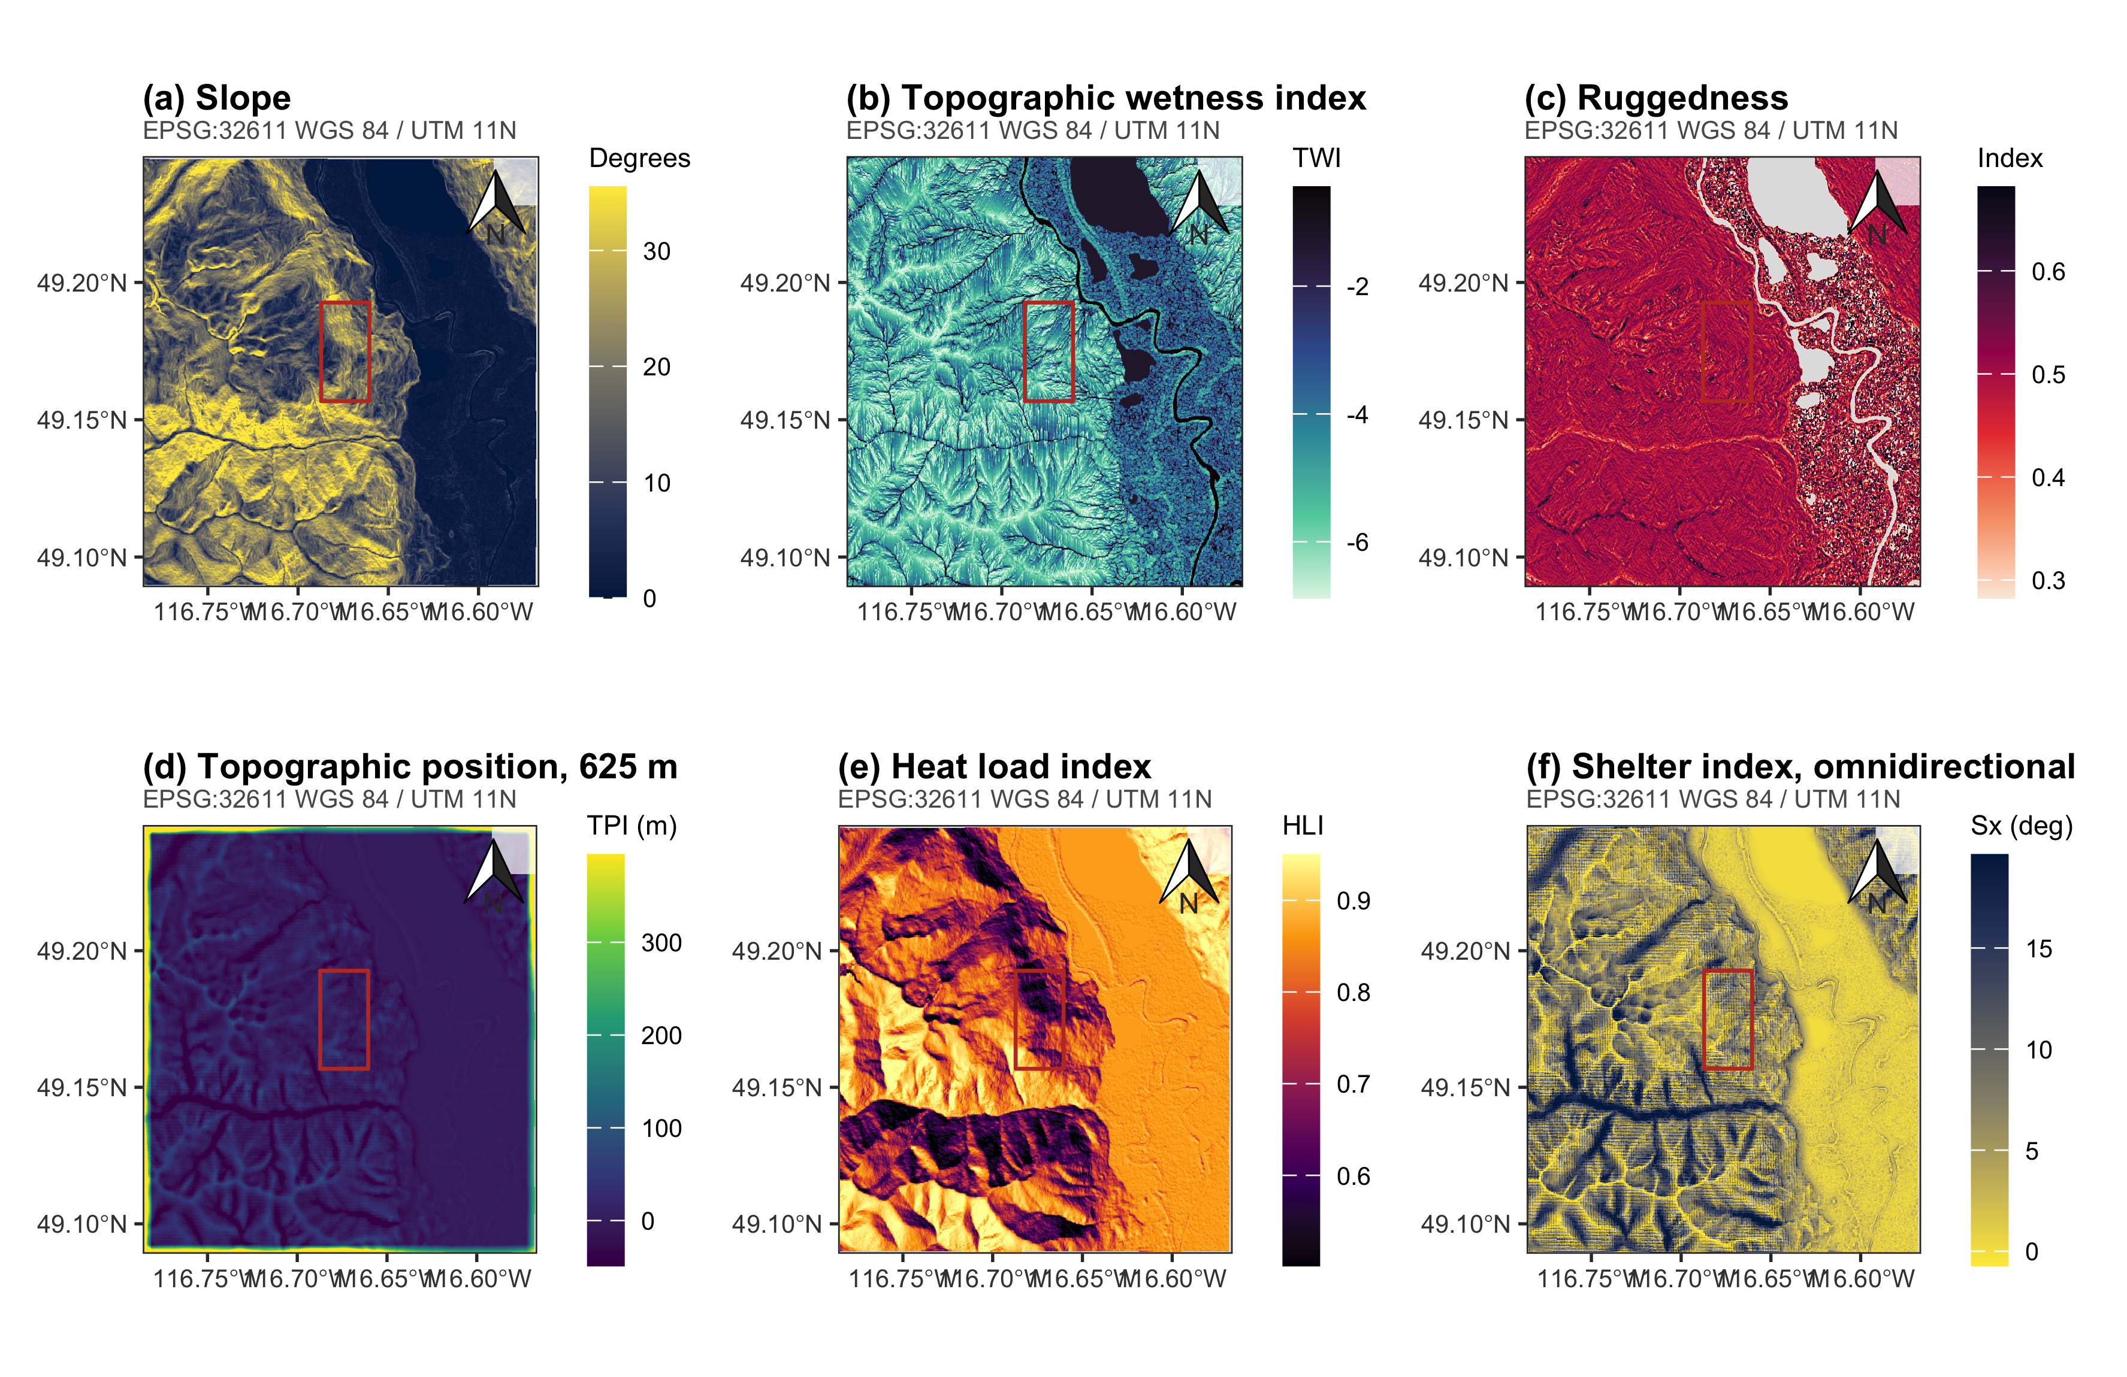
Figure S2. The weather station network behind the cold argument. All stations within 100 km reporting a usable winter minimum between 1999 and 2015, shaded by station elevation, with the analysis grid outlined. Only the two stations named in the text are labelled. The alpine station and the valley stations near the international boundary reach comparable minima, which is the cold-air pooling the text describes.
fig_station
